**Form builder**

**Description**

Form Builder is used to create forms by the End User with the help of in built component.

**Typical Usage Scenario**

* Form Builder can be integrated into various applications, particularly in small team collaborations, to enable to creating forms by the End Users.

**Pre-requisites**

* Deep Link from Marketplace
* Mx Model Reflection from Marketplace

**Features and Limitations**

* Text Box
* Text Area
* Date Picker
* Check box
* Drop Down
* Radio button
* Slider
* Rating
* Counter
* Integer Box
* Switch button
* Date Range

Text Box-

The text box serves the purpose of displaying and, if necessary, enabling the end-user to modify the attribute value of an object in a textual format.

Check box-

The Check box widget is employed to exhibit and, if desired, enable the end-user to modify the attribute value of a Boolean data type. It shows a tick mark when the value is true and remains empty when it is false.

Slider-

The Slider widget permits the user to set a value by manipulating a slider. It requires configuring both a minimum and a maximum value, defining the boundaries of the slider's track. The user can then adjust the value within these established limits

Drop Down-

The drop-down menu is utilized to present and, if needed, permit the end-user to edit the attribute value of an enumeration data type.

Date Picker-

The date picker is employed to present and, if desired, enable the end-user to modify the value of an attribute of the Date and Time data type.

Text Area-

The text area serves the purpose of displaying and, optionally, enabling the end-user to edit the value of an attribute of the String data type. Unlike a text box, it allows the value to be displayed over multiple lines

Rating-

To utilize the Rating widget, which allows rating from 0 to a specified maximum, you must integrate it into a data container with an Integer, Long, or Decimal attribute.

Counter-

The Counter activity allows incrementing a metrics counter by a specified value.

Integer Box-

The Integer Box widget is a user interface element that accepts only finite integer values as input. It provides a text input field where users can enter numerical values, and it enforces the constraint that only whole numbers (integers) are allowed.

Date Range-

The Date Range Picker widget is a user interface element that allows the user to select a range of dates. It provides a visual calendar or date picker interface where users can choose a start date and an end date to define a specific range.

Switch-

The Switch widget is a user interface element that allows the user to toggle a Boolean attribute, typically representing an on/off or true/false state.

**Dependencies**

* Requires Mendix Version 9.24.2 or above

**Installation**

* Login as administrator to create a form.

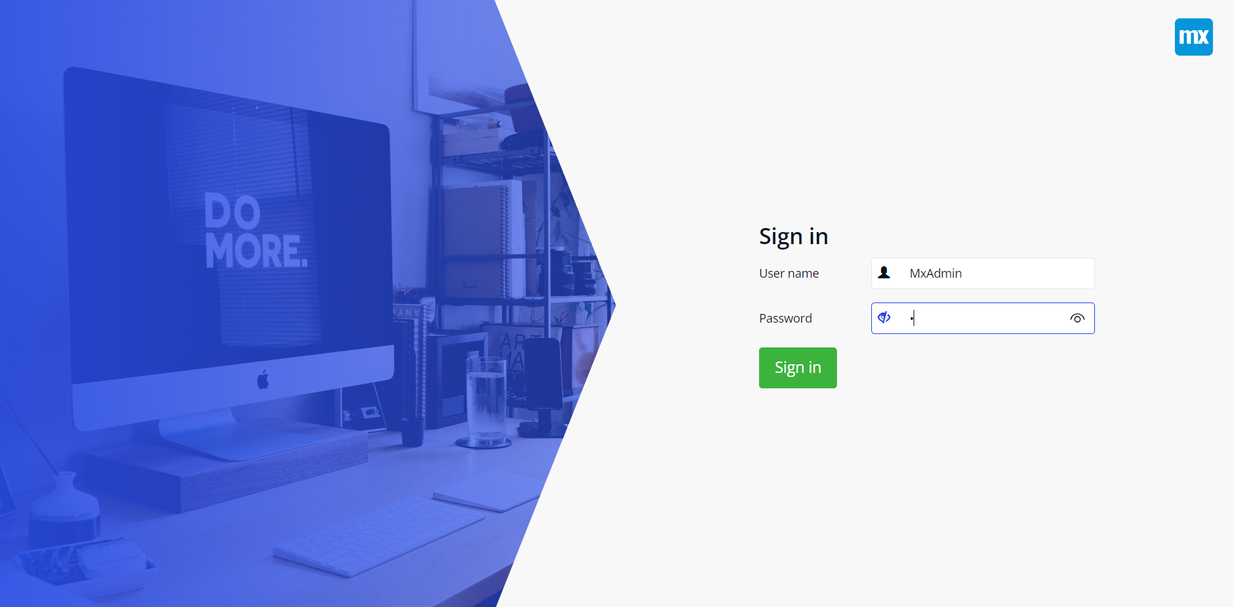

* Home page will be shown. Click on the new Button to create form. A screenshot of a computer

  Description automatically generated
* Please complete all the required fields and ensure that the "create DeepLink" switch is turned on if you wish to generate a link for the form. You can choose to either enable responses until the administrator disables them or set an expiry date with a specific number of form submissions. Once done, click on "Save" and proceed to the next step.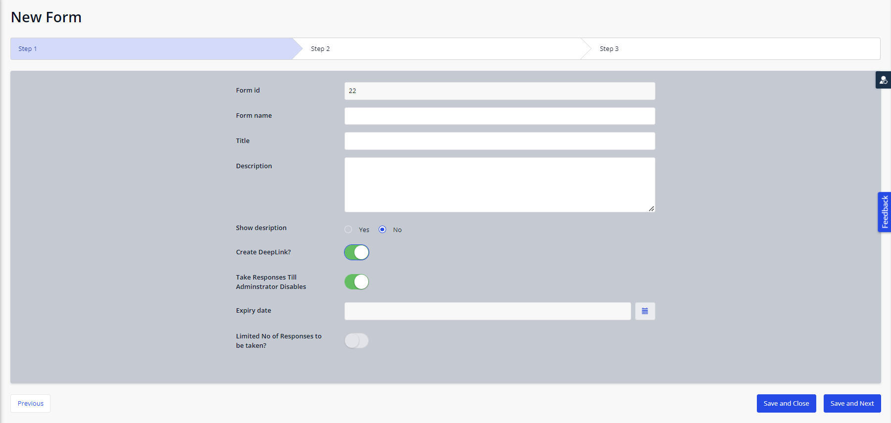
* In next step, click on new add form fields.A screenshot of a computer

  Description automatically generated
* A list of widgets is available to choose for your form. Select Field type one by one as per your requirement.A screenshot of a computer

  Description automatically generated
* For Field types(Radio Button, Drop-Down, Check Box), you can add different options for the chosen field.A screenshot of a computer

  Description automatically generated
* Click new and add options.

* You can add as many fields as required.A white screen with many lines

  Description automatically generated
* You can see your form with the form link and save it. A screenshot of a computer

  Description automatically generatedA screenshot of a computer

  Description automatically generated
* Now Click on DeepLink**(-)** menu item. 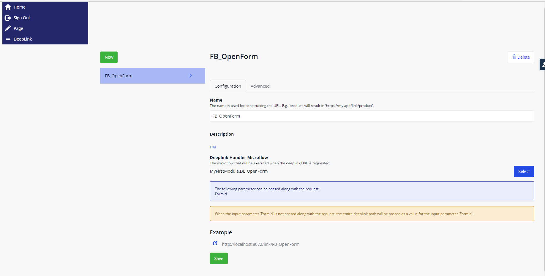
* Here , you can see the link is created. Copy the given link from here and paste it on incognito mode with (/FormId).For example-  
  <http://localhost:8072/link/FB_OpenForm/22>   
  Or just get the form link from “All Forms” and paste it in new private window.  
  A screen shot of a computer

  Description automatically generated
* Now sign in as user.  
  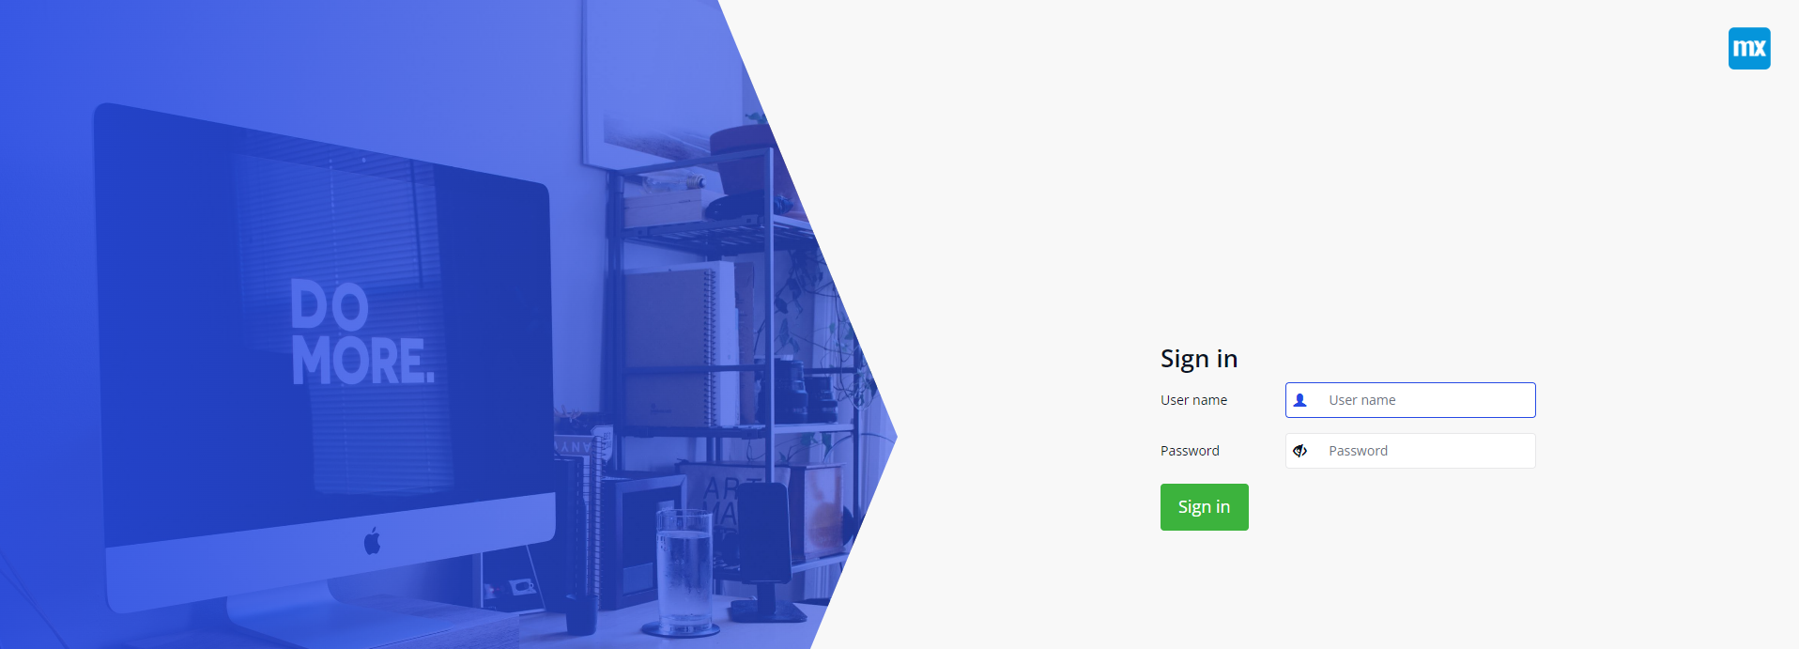
* Enter the form details and save it. A screenshot of a computer

  Description automatically generatedA screenshot of a computer

  Description automatically generated
* Go to Form Names and select your form name. Now click on Show response button to see your responses once.A screenshot of a computer

  Description automatically generated
* Now you can see your responses here.A screenshot of a computer

  Description automatically generated
* You have created and filled your form successfully.

**Configuration: NA**

**Category: Module**

**Subcategory: All**

**Visibility: Public Marketplace**

**Studio Pro Version: 9.24.2**